Programming Assignment #2
(for Ch 3)

Problem Description

Create a class called Date that includes three pieces of information as instance variables—a month (type int), a day (type int), and a year (type int). Your class should have a constructor that initializes the three instance variables and assumes that the values provided are correct. Provide a set and a get method for each instance variable. Provide a method displayDate that displays the month, day, and year separated by forward slashes (/). Write a test application named DateTest that demonstrates class Date’s capabilities.

Note: This problem is question 3.15 on page 101.

Sample Run

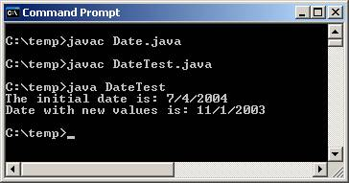 | Hint:  Date date1 = new Date( 7, 4, 2004 );  System.out.print( "The initial date is: " );  date1.displayDate();  // change date values  date1.setMonth( 11 );  date1.setDay( 1 );  date1.setYear( 2003 );  System.out.print( "\nDate with new values is: " );  date1.displayDate();  System.out.println(); // output a newline

Problem Requirement
a) You must create a file named Date.java that contains the class Date.
b) You must create setMonth, setDay, setYear, getMonth, getDay, getYear, and displayDate methods.
c) You must create another file named DateTest.java that contains the class DateTest with the code given in the above Hint.
d) Your program should run correctly with the same inputs and outputs as given in the sample run.

